Laboratory Report

LABORATORY 1 – REPORT

Student name: Eromonsele Peniel Clements

Student ID: 18317006
Programme: ME1

I hereby declare that the attached submission is all my own work, that it has not previously been submitted for assessment, and that I have not knowingly allowed it to be used by another student. I understand that deceiving or attempting to deceive examiners by passing off the work of another as one's own is not permitted. I also understand that using another's student’s work or knowingly allowing another student to use my work is against the University regulations and that doing so will result in loss of marks and possible disciplinary proceedings.
Signed: Eromonsele Peniel Clements | Date: 28 February 2019
Note: Coursework examiners are entitled to reject any coursework which does not have a signed copy of this form attached or are submitted late.

Task 1
Write a program that first reads the number of people who bought soccer tickets. For each person, it reads the number of tickets bought and prints it in a table: The program should then compute and print the average numbers of tickets bought by soccer fans.

Plan
Write pseudo code to give a skeleton to code
-Create input code
-Read the info
-process the info in the loop
-Print the output which is the average and the table

Type code into Textpad
Compile program
Execute the program
Exit program

Development

I included the relevant libraries and a new one ctype.h because I thought I would need it but it was not necessary. I assigned the various data values (int clients, i and float average and total). I realized I needed to get the inputs from the user so I created that section of code. Then I created a loop that would repeat itself so it would ask the number of each tickets each person bought. It records these values and adds the total amount of tickets. The next course of action is to create the table described in the task, a loop is created here to display each person and their tickets. Finally the code gets the average by taking the total and dividing it by the number of people

Testing

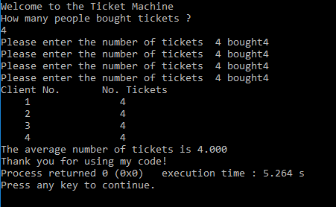

Conclusion

I have learned a lot about loops and their power. The for loop is a useful loop if you want a function to repeat something for a certain length. I learned about the \t function for text and how to use it to get the required table.

Code
#include <stdio.h>
#include <stdlib.h>
#include <ctype.h>
#include <string.h>
int main()
{
int clients, i ;
float average,total ;
printf("Welcome to the Ticket Machine\n");

/* input */
printf("How many people bought tickets ?\n");
scanf("%d", &clients);
int tickets[clients];

for (i=0; i<clients; i++){
printf("Please enter the number of tickets %d bought", clients);
scanf("%d", &tickets[i]);
total =total+tickets[i];

}
printf("Client No. \t No. Tickets\n");
for (i=0; i<clients; i++){
printf(" %d\t\t",i+1);
printf(" %d\n", tickets[i]);
}
average = total/clients;
printf("The average number of tickets is %1.3f\n", average);

printf("Thank you for using my code!");

return(EXIT_SUCCESS);

}

Task 2
Write a program that prints the following patterns decribed in the task separately, one below the other. Use “for” loops.

Plan
Write pseudo code to give a skeleton to code
-define a row of asterisks and use a loop to repeat the lines
-form a row of one asterisks and decrease it by one each time
-Repeat but flip
Type code into Textpad
Compile program
Execute the program
Exit program

Development
The first step in the development of my program was to include the standard C libraries (stdio.h, stdlib.h,) that in order to be able to use certain functions in the program.

Then, I started to write the main function of the program. I used for loops to repeat the processes of placing the asterisks. I assigned i and j values to get the square and right hand triangle and finally I put in my welcome and goodbye messages.

The result is then printed to the screen, using the “printf” statement.

Testing

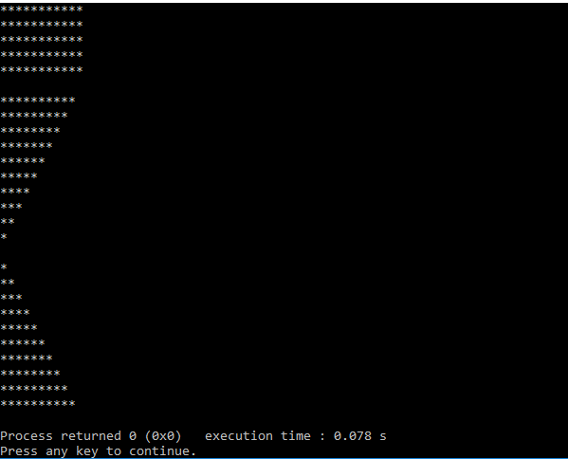

Conclusion

During this lab session I learned about the increasing and decreasing power of the for loop and how I can use it to form shapes using asterisks Also the errors I obtained helped me understand that you must double check your code constantly to make sure it is correct. Trial and error really helped in figuring this task out

The final version of the C source code for task 1 is attached as task3lab.c

Code

My development resulted in the following source code:

#include <stdio.h>
#include <stdlib.h>
#include <ctype.h>
#include <string.h>

int main()

{
int i, j ;

for(i=0; i<5; i++){
for(j=0;j>11; j++);

printf("***********\n");

}
printf("\n");

for(i = 10; i > 0; --i){
for(j = i; j > 0; --j){
printf("*");
}
printf("\n");
}

for(i = 0; i < 11; ++i){

for(j = i; j > 0; --j){
printf("*");
}
printf("\n");
}

}

Task 3

You are required to develop a program which will input a series of lines of characters, and encode them with a Caesar cipher. As each line of plaintext is input, the corresponding line of ciphertext should be output. It is up to you to devise a mechanism whereby the user can indicate that all lines have been input, and to implement the program in such a way that it will then terminate.

Plan
Create pseudo code to create this function
-Create input questions
-scan the message
-Ask user for desired key
-Define the allowed inputs and add the desired key to them.
-Print encrypted message
Type code into Textpad
Compile program
Execute the program
Exit program

Development
The first step in the development of my program was to include the standard C libraries (stdio.h, ) that in order to be able to use certain functions in the program..
I entered my input questions and the desired key question. I then defined the allowed inputs. The input of the user and their desired key allow for the code to be encrypted by whatever the key was. It is then printed out

.

Testing
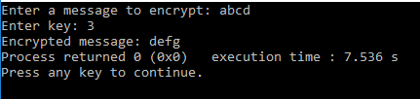
The testing was done through putting various words into the code

Conclusion
Encryption is a useful way of protecting your data. I can see from this type of encryption that this is a very simple way of encrypting data and there must be more advanced way.
The final version of the C source code for task 3 is attached as Task4lab5.c

Code
#include<stdio.h>

int main()
{
char message[100], ch;
int i, key;

printf("Enter the message you want to encrypt: ");
gets(message);
printf("Enter key: ");
scanf("%d", &key);

for(i = 0; message[i] != '\0'; ++i){
ch = message[i];

if(ch >= 'a' && ch <= 'z'){
ch = ch + key;

if(ch > 'z'){
ch = ch - 'z' + 'a' - 1;
}

message[i] = ch;
}
else if(ch >= 'A' && ch <= 'Z'){
ch = ch + key;

if(ch > 'Z'){
ch = ch - 'Z' + 'A' - 1;
}

message[i] = ch;
}
}

printf("Encrypted message is : %s", message);

return 0;
}

My development resulted in the following source code:

